How to use and care for your
Garvey Contact® Labeler
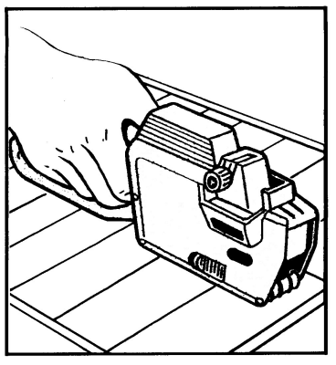

You have purchased a quality product in this Contact® Labeler by Garvey. Please study the instructions, handle with care and you will receive long time service and satisfaction.

HANDLING INSTRUCTIONS
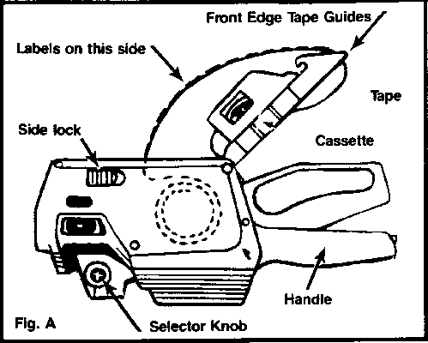

TO LOAD LABEL GUN
Press both side locks and open bottom cassette. Insert tape as shown in Fig. A. Thread tape under front edge tape guides (Fig. B) and close cassette until it snaps.
Feed tape between feed drive wheel and roller. Squeeze the handle 6 or 7 times. The tape will feed through the gun. Set print head to desired setting. The gun is now ready to use.
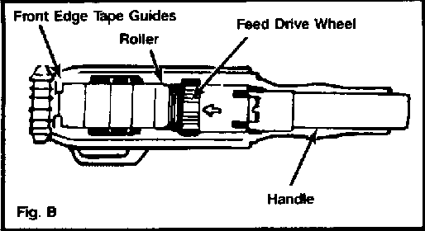

SETTING THE PRICE CODE:
Pull selector knob (Fig. C, No. 4) out to desired position shown by selector indicator (Fig. C, No. 5) and turn knob. The white number (Fig. C, No. 2) appearing in the window will be the same as number printing. Always be sure that the white portion of the band is displayed in the window.
IMPORTANT:
Band selector indicator must be positioned as shown in Fig. C before operating gun.
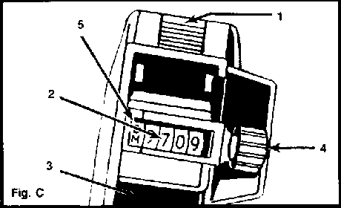

SLUGS:
Optional printing slug can be inserted in open slot at back of printing head (Fig. C, No. 3).
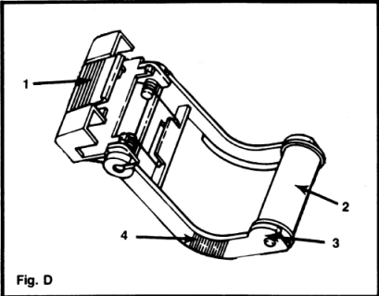

TO REMOVE INK ROLLER CARRIAGE:
Squeeze handle, exposing ridged areas (Fig. D, No. 4) of carriage, with thumb and index finger, pull carriage outward. To remove ink roller (Fig. D, No. 2) spread carriage legs apart (Fig. D, No. 3). Roller will drop out.
TO REPLACE INK ROLLER CARRIAGE:
With thumb and index finger, insert carriage lip (Fig. D, No. 1) into small rectangular opening at top/front of gun at a 30-45 degree angle, when lip is fully inserted into opening simply push carriage in and downward.

IMPORTANT NOTICE!!!
THE USE OF NON-GENUINE GARVEY PRODUCTS WILL VOID THE MANUFACTURER'S WARRANTY.
ANY LABELERS DETERMINED TO HAVE BEEN USED IN CONJUNCTION WITH NON-GENUINE GARVEY PRODUCTS WILL BE RETURNED TO THE CUSTOMER, UNREPAIRED, AT THE CUSTOMER'S EXPENSE.
IF YOUR SUPPLIER IS NOT SELLING GENUINE GARVEY PRODUCTS AND YOU WOULD LIKE INFORMATION REGARDING AN AUTHORIZED GARVEY RESELLER IN YOUR AREA, PLEASE CALL LINDA AT OUR TOLL FREE NUMBER, (800) 543-1908.

